# begin

int a, b, c a,b != 0

begin

# delta = (b*b)-(4*a*c)

if delta > 0

x1 = -b+sqrt(delta)/(2*a) x2 = -b-sqrt(delta)/(2*a)

display phuong trinh co 2 nghiem x1, x2

else if delta == 0 x1 = x2 = -b/(2*a)

display phuong trinh co nghiem kep x1

else

int a, b, c

a, b != 0

true

false

# end

display phuong trinh vo nghiem end if

delta = (b*b)-(4*a*c)

delta > 0

false

display phuong trinh vo nghiem

true

x1 = -b + sqrt(delta)/(2*a)

x2 = -b - sqrt(delta)/(2*a)

display phuong trinh co 2 nghiem x1, x2

false

delta == 0

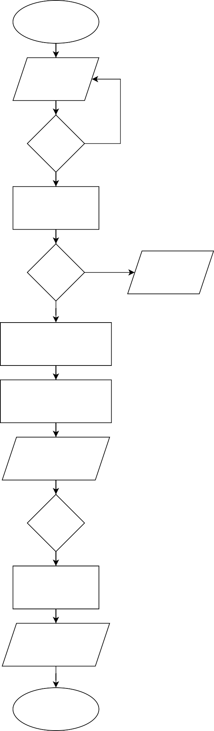

true

x1 = x2 = -b/(2*a)

display phuong trinh co nghiem kep x1

end